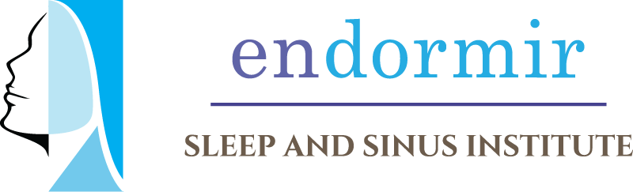
Endormir Sleep and Sinus Institute
14603 Huebner Rd, Bldg 1 San Antonio, Texas 78230
Phone: 210-468-5426
Fax: 210-764-5440

BELL’S PALSY

Bell’s Palsy is a benign weakness of the facial nerve. It is usually self-limiting and is not life threatening. Bell’s Palsy manifests itself by the sudden onset of partial or total paralysis of all the muscles on one side of the face. This usually occurs following a viral infection. Bell’s Palsy will improve in 4-6 months and almost always by 12 months.

Grading System
I. Normal
II. Slight Asymmetry
III. Forehead motion present; eye closure with maximal effort
IV. Forehead motion absent
V. Twitches
VI. Completely out

Treatment
Patients are usually given instruction to use eye drops during the day, an ointment and a moisture chamber at night to protect the eye on the effected side. If a moisture chamber cannot be tolerated, tape the eye shut. Steroids and Acyclovir (Zovirax) may be used to lessen the symptoms in severe cases however; the symptoms will typically improve spontaneously with no treatment.
With those who have only partial recovery and are concerned by the effects, there are other options. A weight can be surgically placed to help the eye lid close. Surgeries to help pull the side of the face and mouth up are also possibilities.

Prognosis
The prognosis is typically good with 86% of patients having a complete recovery. Risk factors for incomplete recovery include:
• Age over 55 years
• Hypertension
• Complete facial weakness
• Pain other than ear pain
• Changes in tearing

